[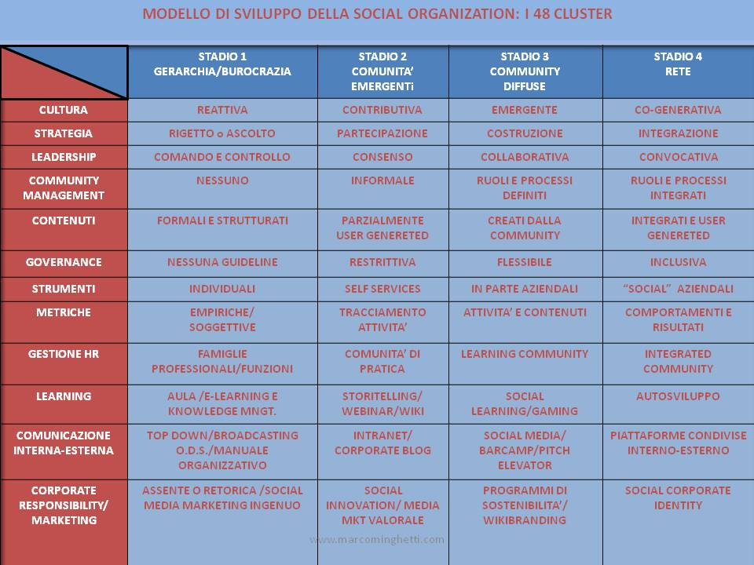](http://www.cervari-consulting.com/wp-content/uploads/humanistic-management1.jpg)